Enquiry Curriculum Map YEAR 1 TERM 5
This map shows areas of study for Year 1 and gives you a flavour of the questions we will be investigating. Within each area the learning and expected outcomes will be scaffolded appropriately for your child.
Mathematician
Count forwards and backwards to 100.

Read numbers up to 100.

Count forwards and backwards in steps of 5 and 10 up to 100.

Write numbers to 50 neatly and know the place value of each digit. (Tens and ones)

Know that numbers from 10 to 20 are made up of tens and ones.

Count out sets of 11 to 20 objects.

Number facts and arithmetic writing expressions and equations within 20.

Find halves and quarters of shapes and sets of objects.
Read and draw half past times on a clock face.

Scientist

How are animals the same and different?
How can we group animals?
What are our five senses?
What are the key features of mammals?

What is a plant?
What are the parts of a tree?
Where and how do fruits and vegetables grow?

Computer Engineer
Digital writing
Using a computer to create and format text, before comparing to writing non-digitally.

PE
Swimming – Thursday afternoons
Athletics

Enquiry Questions:
What are we?
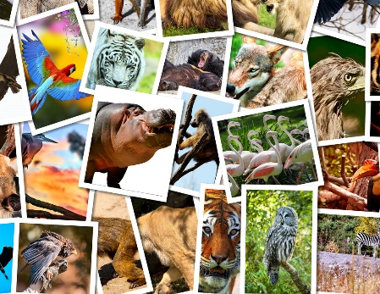

What grows near me?
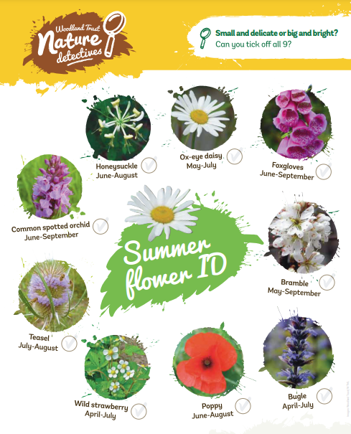

Writer / Author
Focus on writing sentences with correct and consistent punctuation: Capital letters, full stops, question marks, exclamation marks, capital letters for the names of people and places.

Write in the correct present or past tense.

Spell words ending in: ing, ed, est, er.
Spell words with the prefix: un

Spell Year 1 keywords correctly within sentences and read own writing back to an adult. With support, identify spelling errors and make necessary corrections.
Neat and accurate presentation of written work: forming letters accurately and placing letters correctly in relation to the line. Show l,t,b,d,h,k a little taller and g,j,p,q and y with “tails” below the line.

Using the book ‘Meerkat Mail’ by Emily Gravett:
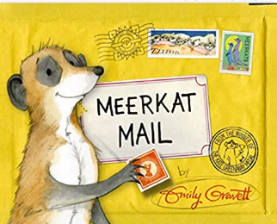
- Retell the exact story
- Write postcards between characters and to describe locations
- Write own invented story about a travelling Meerkat
- Write non-fiction information related to Meerkats and mammals

Musician
Use their voices expressively and creatively to sing a range of songs.

Philosopher: RE
What makes some places sacred?
(Christianity and Judaism)

Philosopher: PSHE
Relationships
I understand there are lots of different types of families.
I know what being a good friend means to me.
I know which forms of physical contact are acceptable and unacceptable to me.
I can recognise my qualities as a person and a friend.
I can tell you why I appreciate someone who is special to me.

Artists
Use sketching skills to draw features of different plants and animals.

Explore how to show the form, texture, lines, patterns and colours of a mammal to make an animal sculpture?

Ideas to support your child at home:
Count forwards and backwards together within 100: counting back is proving trickier for many children. It may help to use a number square as a prompt to remember the next number. Pop into class for a number square if you would like one. Use 10p coins and 1p coins to make totals up to £1. This will help the children to understand place value and identify how many tens and ones are in numbers up to 100.
Talk about what makes your family unique and celebrate the qualities of each member of your family. Help your child to be able to talk about their special qualities and the things they appreciate about friends.
Share your thoughts and observations about the variety of plants in our locality and inspire the children’s curiosity and desire to look after them and encourage the wildlife that inhabits and rely on them.

