Enquiry Curriculum Map YEAR 1 TERM 1
This map shows areas of study for Year 1 and gives you a flavour of the questions we will be investigating. Within each area the learning and expected outcomes will be scaffolded appropriately for your child.
Geographer/Historian

Observe and explore the seasonal changes in plants and animals associated with Autumn.

Observe how Autumnal weather changes and how day length varies.
Make tables and charts to show changes in the weather.

Engineer/Artist
Artist study: Yayoi Kusama and Damien Hirst
How do artists create designs using circles and dots in different way?
Design and create their own dot and circle art.
Design, make and evaluate their own hat.

Fine motor skills: drawing, mark making and patterning with a range of equipment, cutting with scissors, threading, lacing, making patterns with small objects etc.

Exploring and displaying Autumn finds.

Mathematician
Learn to recognise small amounts without needing to count them – subitising.

Know that whole amounts to 10 can be split into 2 parts and be able to use sentences such as “I have 3 and I have 6, together they make 9”

Count to at least twenty, forwards and backwards, beginning with 0 or 1, or from any given number.
Count, read and write numbers to 10 in numerals and words.
Given a number to 10, identify one more or one less.
Recognise odd and even numbers to 10.
Count in steps of 10.
Read O’ Clock times.
Measure the length and height of objects.

Computer Engineer
Learn how to log on to the computer typing own surname and agreed password.
Use and programme controllable toys to give and follow instructions using forwards, backwards, left and right, whole, half and quarter turns.
Plan and test a sequence of instructions.

Enquiry Questions:
How does Wick change in Autumn?


What could my hat be made from?
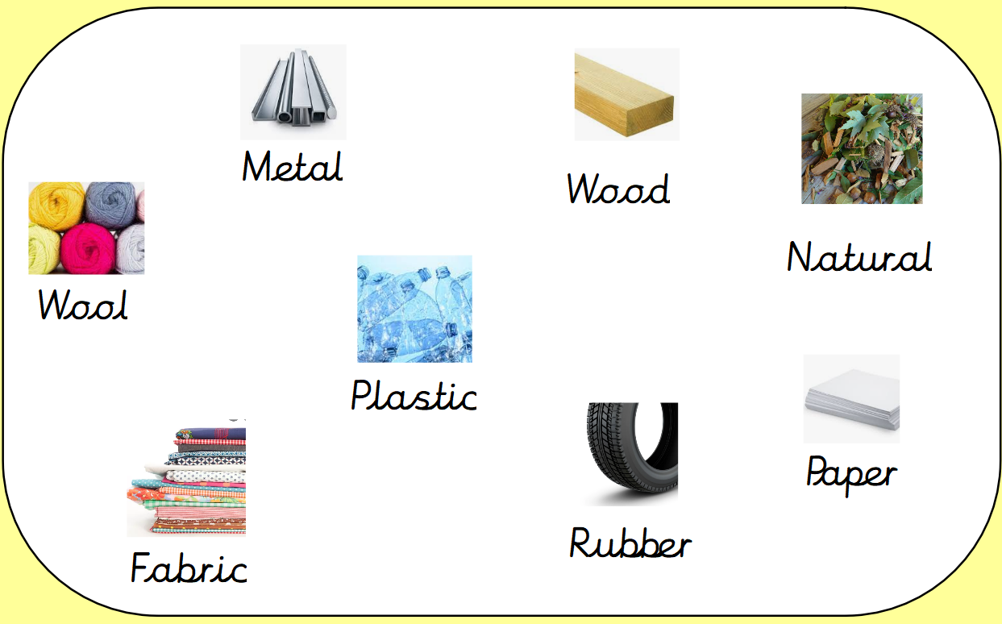

Writer / Author

Share ideas with others and be able to say what they will write. Speak in sentences ahead of writing in sentences.

Write letters that are correctly formed and can easily be read by others.

Spell words by identifying the sounds in them.

Spell the Reception Tricky words accurately and independently.

Write simple labels, captions, phrases and sentences that they can read back to others.
Musician
Begin to sing in tune with an awareness of pulse and rhythm.
Identify the beat and join in with getting faster and slower.

Philosopher: RE
Who is a Christian and what do they believe?

Philosopher: PSHE
Being Me in My World
Settling into a new year group, talking about the changes in expectations and routines. Develop a sense of belonging in Deer Class. New beginnings, self-confidence.
Talking about different feelings and emotions and naming them.

Athlete

Scientist

Ask and begin to answer questions about materials.

Explore what different objects are made from and name the materials: wood, metal, plastic, glass, fabric, paper, cardboard, water, rock, brick, elastic, foil.

Compare and group items together on the basis of their properties such as comparing strength and what the best material to make a hat for a particular purpose could be.

Ideas to support your child at home:
Simple counting forwards to 100 and backwards from 10 or 20; the ‘teens’ numbers are often the hardest to learn. Talk about o’clock times in the day and show the children the position of hands on clocks and watches at these times. Play dice games where the children learn to recognise the number of spots without needing to count each one. Enjoy family walks and talk about the nature around you and seasonal changes including how it is getting darker earlier each evening.

