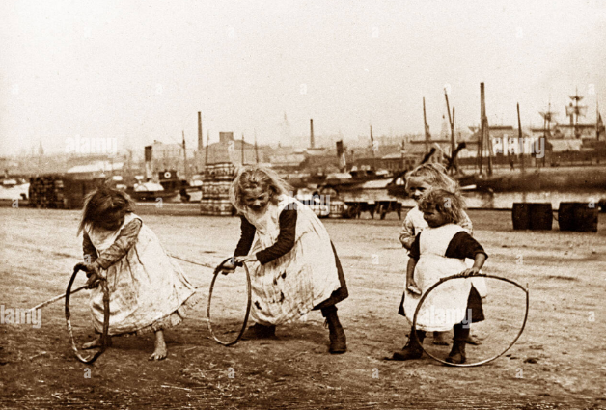 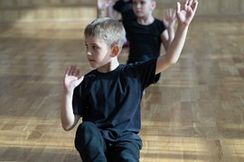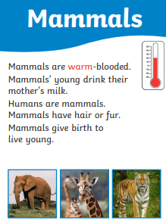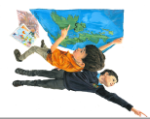

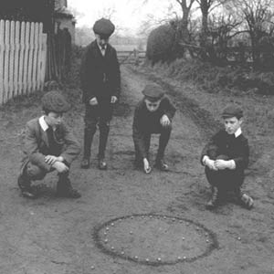

**States of being –** Historian

We will be learning that the present is different to the past and that we cannot go back to the past. Most things change over time and the way people do things also changes over time, such as playing games.

Challenge – To create a ‘Game Box’ which has everything a group of children need to play the game, including instructions and photos / illustrations.

=======

How can we play in different ways?

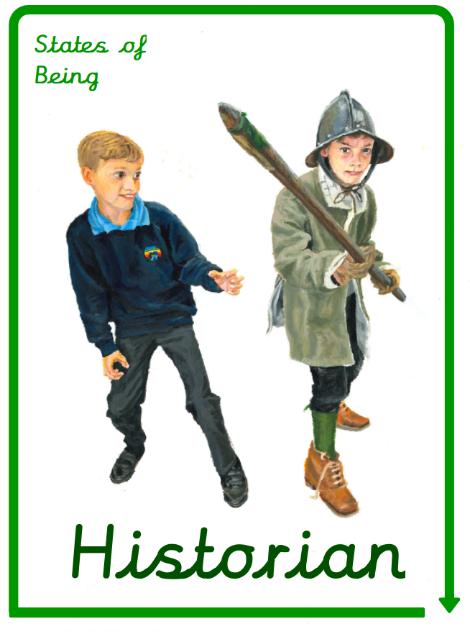

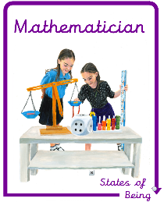

How do we move around?

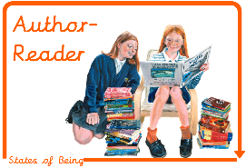

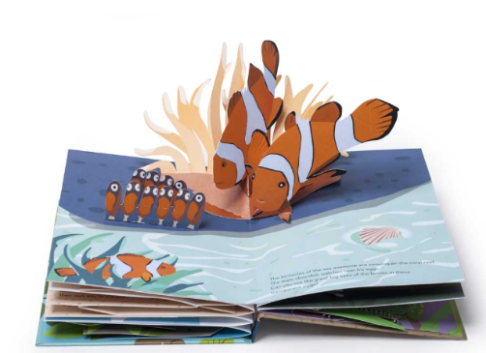

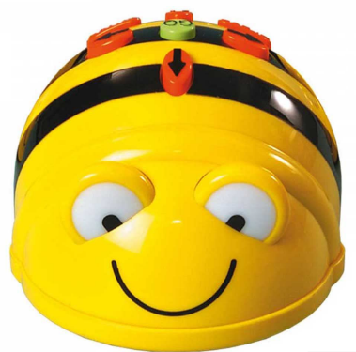

**States of being –** Mathematicians and Authors.

We will be looking at how things move! The children will be investigating how animals move within our school and local area. They will have the opportunity to make and test different moving parts before finalising their ideas and making their own ‘pop-up book.’

Challenge – Learners will create an illustrated ‘pop-up’ book about the school and local area, focussing on animals and people that move around in it.