
Wick CE Primary School
Church Road
Wick
Bristol
BS30 5PD
TEL: 01179372399 Fax: 01179373250
Email: WickPrimary.School@southglos.gov.uk

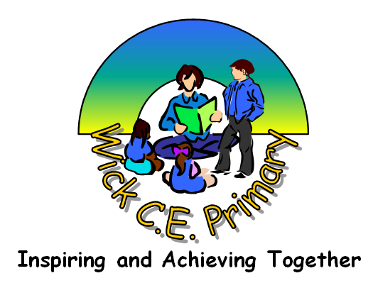
Headteacher
Mr Robert Cockle
BSc (Hons) NPQH

4th September 2023
Dear Parents,

Welcome to year 4! I am really looking forwards to getting to know your child this year – we have a great year planned!

I will be in class all week with the exception of Monday and Tuesday afternoons where your child will be taught by subject specialist teachers. This includes P.E., Spanish, Computing and Music. If you need to catch up with me, my door is always open just before school starts or at the end of the day otherwise send a message to the office and I can arrange a time to meet or call you. Mrs Jenkins will be our class TA every morning.

PE: Please ensure your child wears their PE kit to school on a Monday and Wednesday when they will have PE. On a Monday, they will be taught by specialist PE coaches. May we remind you that long hair should be tied back and earrings removed or covered for PE. Please provide tape to cover earrings if they are not being removed.

Homework: This will be set on a fortnightly basis for Spelling. Please help your child to learn their spellings as they will be tested on them at the end of the two-weeks. These will be stuck in their reading records. Maths will be handed out weekly every Wednesday in a folder and should be handed back in on Monday. For the term, there will be optional activities linked to our enquiry – also stuck in their reading records. These will be fun, creative activities they can choose from.

Reading: Please continue to support your children by hearing them read regularly. Children are required to read 5 times a week. Each week, their reading records will be collected in and their reads counted. As this number goes up they can win certificates and badges! Please initial each time you read with them.

Times Tables: Times tables are really important for our year 4 children as we have a X tables check this year. This will be 25 questions fired quickly and they must get all of them correct to pass. Please can you support you child in becoming fluent with these through playing games with them and giving them access to Times Table Rockstars. Keep an eye out for the Rock Star battles!

Water bottles: Please ensure your child brings a labelled bottle of water to school each day. The children are advised to take their bottles home each evening to wash them and bring them back refilled the next day.

Thanking you in advance for your support and cooperation.
With best wishes,

Georgia Player

