Enquiry Curriculum Map
This map shows areas of study for Year 3 and gives you a flavour of the questions we will be investigating. Within each area the learning and expected outcomes will be scaffolded appropriately for your child
Geographer
As geographers we will be locating the different continents and oceans on maps as well as the equator, southern and northern hemispheres. We will look at daylight hours in The Arctic and The Antarctic and what it would be like to live in the land of the midnight sun.

Engineer/Artist
As engineers we will be designing a shadow puppet theatre complete with shadow puppets with movable joints to retell the story of Can’t you sleep Little Bear?
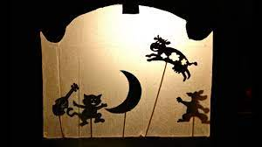

Mathematician
As mathematicians we will be looking at the place value of 3 digit numbers and exploring numbers up to 1,000. We will learn to use column addition and subtraction for 3 digit numbers, building on methods used in year 2.
We will revise our 3 times table.

Where does the darkness come from?

Term 1

Year 3

Computer Engineer
As a computer engineer, we will be identifying that digital devices have inputs, processes, and outputs, and how devices can be connected to make networks.

Musician:
As musicians, we will be
finding rhythmic patterns in music and adding accompaniments with instruments to the songs we are learning.
Philosopher: PSHE
As philosophers, we will be looking at Being me in my world.
Philosopher: RE
As philosophers, we will be thinking about what it means to be a Hindu living in Britain today.
Athlete
As athletes, we will be focused on learning the skills of football with the sports coaches and with Mrs Stone looking at orienteering.
Linguist
As Spanish linguists, we will locate Spain on a map, learn to greet others and introduce ourselves. Learn numbers to 12.

Author
As an author, we will be using the book The Mousehole Cat as our core text. From this we will write setting and character descriptions using noun phrases and adverbs and diary entries. Our final outcome will be to re write the story in our own words. We will also use it to write a newspaper report, diary entry and persuasive advert.
As part of our enquiry into darkness we will then perform a playscript based on the book, Can’t you sleep Little Bear? to perform with our shadow puppets.
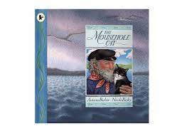

Scientist
As scientists, we will be learning that light comes from a source and that we need light to see. We will experience the dark to show that dark is the absence of light. We will investigate ways light is reflected from different surfaces.
We will investigate shadows and understand that when the light is blocked a shadow is made.

