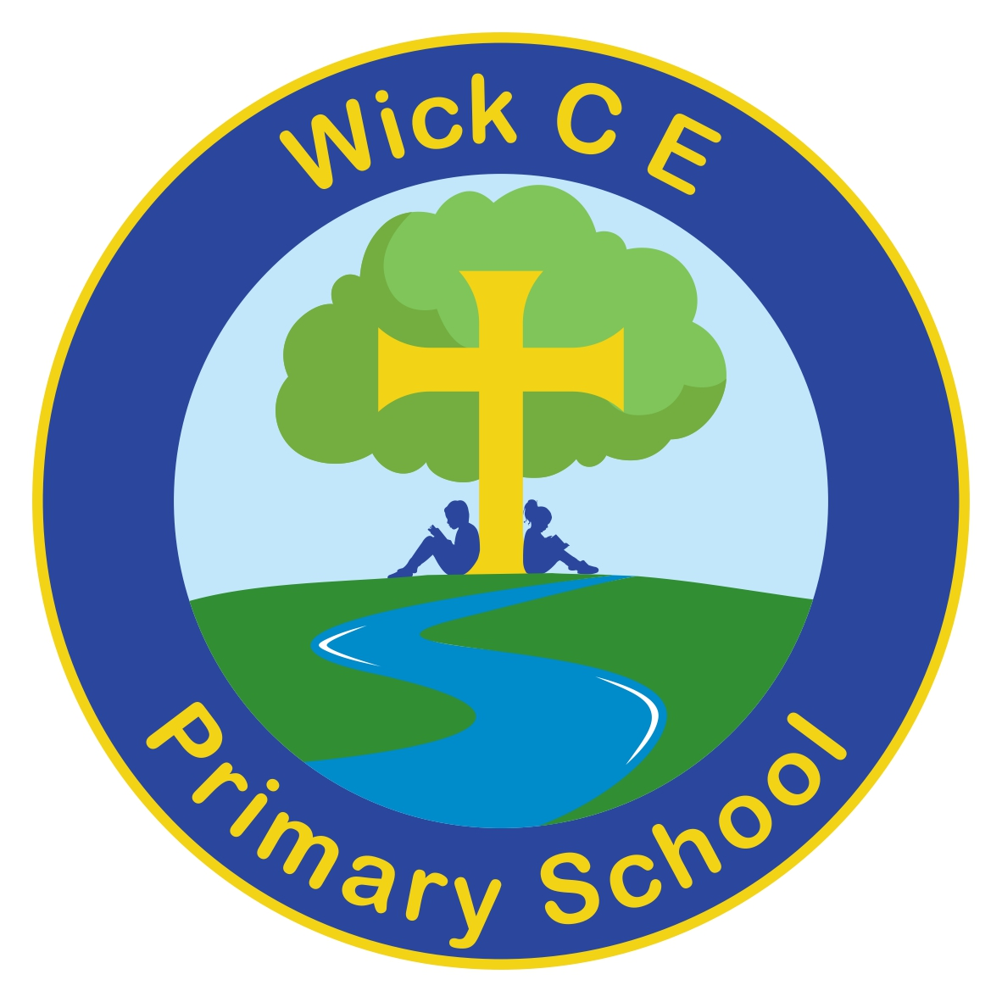

Executive Head
Mr Robert Cockle
BSc (Hons) NPQH

Head of School
Mr Christopher Nesbitt
BEd (Hons) NPQH

Wick CE Primary School
Church Road
Wick
Bristol
BS30 5PD
TEL: 01179372399
Email: office@wickprimary.org.uk
Website: www.wickprimaryschool.co.uk
Twitter: @WickPrimary

‘Wherever the river flows,
life will flourish.’

7th September 2024
Dear Parents,

Welcome to year 6. I am really looking forward to this year getting to know your child before they move onto their journey at secondary school.

I will be in class all the time with the exception of Monday and Tuesday afternoons where your child will be taught by subject specialist teachers. This includes P.E., Spanish, Computing and Music. If you need to catch up with me, my door is always open just before school starts or at the end of the day otherwise send a message to the office and I can arrange a time to meet or call you. Mrs Jenkin will be our class TA every morning and Mrs Noble with be with us for three afternoons a week.

Uniform: Please can you ensure that you child is wearing the correct school uniform and that the likes of nail polish and tattoos are removed for the school week.

PE: Please ensure your child wears their PE kit to school on a Tuesday and Wednesday when they will have PE. On a Tuesday they will be taught by specialist PE coaches from Bristol Sport. Long hair should be tied back and earrings removed or covered for PE. Please provide tape to cover earrings.

Homework: Homework will be sent home on a Wednesday to be handed in on the following Monday. The homework will consist of: reading (at least 5 times a week), learning spellings, daily timetable practice (using Times Table Rockstars), a maths sheet and optional enquiry tasks. This year, the reading record will also act as a homework diary with spellings so it is important that it is brought in every day.

Times tables are really important for our year 6 children as these are found in many of the maths topics we will be covering. Even if your child knows their tables practising on TTRS will help them improve their speed and accuracy.

Please continue to support your children by hearing them read regularly. The reads they logged in year 5 will be continued so that they are able to successfully gain their badges. The reading record will need to be handed in on a Monday so we can count the reads and reward the children with the appropriate badges.

I have also set the children up an account with an online grammar programme. On this I will set activities linked to our current learning. Although this is not compulsory, it will be good practice as it is structured in a very similar way to the year 6 SAT’s and has previous SAT’s papers with linked games on in one of the sections.

Water bottles: Please ensure your child brings a labelled bottle of water to school each day. The children are advised to take their bottles home each evening to wash them and bring them back refilled the next day.

There are two key events happening for the year 6 children this year; SAT’s and the year 6 residential. I would like to invite you a meeting on the 12th September at 3.20pm in Woodpecker Class, where we will be able to share some more information about these.

Thanking you in advance for your support and cooperation.
With best wishes,

Beth Stephens
Year 6 Teacher and Senior Leader

Yours sincerely
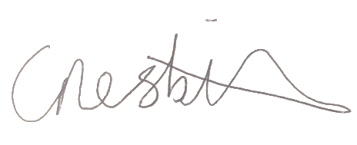

Rob Cockle Chris Nesbitt
Executive Head Head of school

