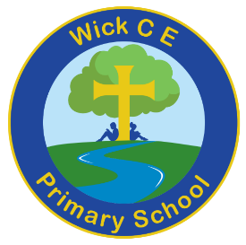
Wick CE Primary’s guide to reading
At Wick, we are keen for our children to develop a love of books and place reading at the heart of our curriculum. Children have lots of opportunities to read throughout the day, access to the school library and we aim to provide them with age appropriate texts as they move through the school.
Reading Badges
Reading badges is our new reward based system for reading at home. Whether your child is an avid reader or someone who needs to discover the joy of reading, the badges give them an opportunity to work towards a milestone. Children move up through coloured ‘badges’ depending on how many times they have read throughout the week. Once a week, we check to see who has read at home by collecting in the reading records to total up the number of reads. In our Celebration Assembly, children, who have reached a milestone for number of reads, will receive their rewards.
Badge | Number of reads
White badge | 15
Yellow badge | 30
Orange badge | 50
Green badge | 70
Blue badge | 95
Black badge | 120
Gold badge | 145
Badge | Number of reads
Yellow star badge | 170
Orange star badge | 200
Green star badge | 250
Blue star badge | 300
Brown star badge | 350
Black star badge | 400
Gold star badge | 450

Badges | Number of reads
Amber | 500
Amethyst | 550
Opal | 600
Turquoise | 650
Ruby | 700
Emerald | 750
Sapphire | 800
Platinum | 900
Diamond | 1000
What counts as a read?
- Reading to an adult or independently (listening to an adult reading to you in KS1).
- This could be a school reading book, a library book or a book from home.
- One read per day counts.
- An adult must sign your planner for each read.
- Write the name of the book in your planner (an adult can help if needed).
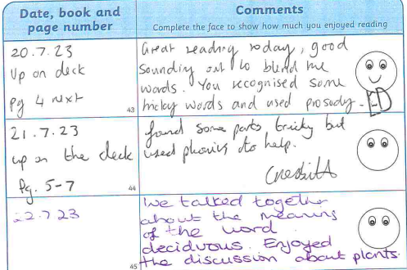
Example of how to fill out your child’s reading planner

