
SEND Information Report
November 2024
SENCO: Miss Ellie Matthews SEN Governor: Liz Butler
Contact: 0117 9372399 WickPrimary.School@southglos.gov.uk
Our local offer can be found on our school Website -
What is a Special Educational Need?
A child is considered to have a Special Educational need if their attainment is significantly below that of age-related expectations and/or they require educational provision that is ‘additional to or different from’ the other pupils in their class. Should a child receive any provision that is in addition to or different from the high-quality teaching that is offered to their peers, they will be placed on the school’s SEN register.
Special Educational needs can be described in four broad areas of need;
Communication and interaction needs; this includes speech, language and communication difficulties including autistic spectrum conditions.
Cognition and Learning needs; this includes children who have learning difficulties and specific learning difficulties like dyslexia and dyspraxia.
Social, Emotional and Mental Health needs; this includes difficulties such as; anxiety, adverse childhood experiences, and ADHD.
Sensory and/or Physical Needs; this includes children who have visual or hearing impairment.
How does the school know if the children need extra help and what should I do if I think my child may have SEN?
Information about your child’s strengths and any needs will be received in school from the child’s previous teachers and from previous educational settings if applicable.
The progress of all pupils is monitored regularly by class teachers and the Senior Leadership Team. We use formal and informal assessments to quickly identify when a pupil is not making expected progress. We then put interventions in place to address the areas of need in partnership with the child and their family.
If parents and carers have concerns about any aspect of their child’s development, they are invited to make an appointment with the class teacher in the first instance, who may then liaise with the SENCo if needed.
How will the school staff support my child?
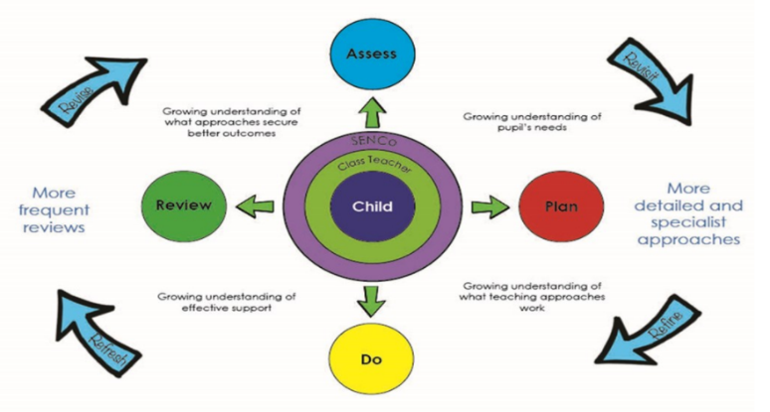
We believe that early identification of special educational needs is crucial and will ensure that each child gets the necessary support in school to help them make progress, meet their potential and help provide the appropriate support for the family if needed.
Your child’s class teacher will continually assess how they are progressing in relation to age related expectations in all areas of the curriculum. This happens in many different ways; for example, through observations, questioning, assessment tasks. If at any point a teacher feels your child may need additional support and provision that is different to that of their peers, you will be informed and the schools SENCO may also become involved.
At this point, in consultation with you, your child is named on the school’s SEN register and you will be informed in writing of this decision. An appropriate plan of action (Support Plan) will be devised detailing provision and measurable outcomes. This action plan is reviewed at regular intervals; at least three times a year, but cycles may be shortened if appropriate. This forms part of the graduated response of assess, plan, do and review and is carried out in collaboration with you as parents/carers who know your child best. We also listen to your child’s views and opinions and they remain at the centre of all decisions made. These views, and the views of any professionals involved, will shape provision and outcomes.
After several cycles of Assess, plan, Do , Review and once we are confident that your child is progressing well with the adjustments we have made, we create an individualised profile that records the additional provision which we know will support your child to be successful. These are written in collaboration with you and your child and are reviewed yearly or if your child’s needs change.
If a child continues to make limited progress despite additional support and they are significantly below age related expectations it may be appropriate, after discussion with parents/carers, to make a referral to an Educational Psychologist or other outside agencies for advice. The specific and expert advice provided by outside agencies will then feed directly into the child’s action plan (Support Plan).
In some circumstances it may be necessary to apply for an Educational, Health and Care Plan (EHCP). If a child has lifelong or significant difficulties they may undergo a Statutory Assessment Process that is usually requested by the school but can be requested by a child’s family. This will occur where the complexity of need or a lack of clarity around the needs of the child are such that a multi-agency approach to assessing that need, planning provision and identifying resources, is required.
More information about the EHCP process can be found on the local offer link.
The SEN Governor (Liz Butler) works closely with the school to help monitor provision and to support the SENCo in her role. The SENCo and Governor meet three times a year to review the provision and the process for supporting children with SEN.
The Local authority also conducts regular reviews of SEN provision and processes at all of its Primary and Secondary schools.

What support will there be for my child’s overall wellbeing?
Children are supported in all aspects of their academic, social and emotional development throughout the school day through the curriculum and extra-curricular activities. Personal, Social and Health Education and Social and Emotional Aspects of Learning are an integral part of our curriculum and also taught explicitly in class and through assemblies as part of our Jigsaw PSHE scheme.
We are a nurturing school and respond to children’s needs sharing any issues which are troubling them as they arise. We run nurture support groups for children with issues that affect aspects of their social or emotional development. These sessions are run by our team of Parent Link specialist practitioners. Children can be referred to them by staff and parents. A tailored package of support is then devised in collaboration with the SENDCo, parents and class teacher. This support is reviewed weekly – Please see the school website for further information on Parent link workers.
We understand that children will not make good progress if there are other factors affecting their wellbeing so we view issues raised by the children themselves or other members of the school community as important and take time to address them. Parent link advisors are available to speak directly with anyone who requests an appointment, and frequently make themselves available on the school playground. Parents can phone or email the office to make an appointment.
We have an Anti-Bullying Policy and Attendance Policy which are available from our website.
What training have the staff supporting children with SEND had or are having?
Teachers, Higher Level Teaching Assistants and Teaching Assistants have a wealth of experience of supporting children with a range of needs, many of which can be quite complex. We regularly update our training through our school professional development programme which includes attending courses run outside agencies and during staff meetings and inset days. Our SENCo, Mrs Barrett, is a qualified teacher who holds the award for National Accreditation for Special Educational Needs Co-ordinations (NASENCO).
What do children at Wick CE Primary School say about how they are supported?
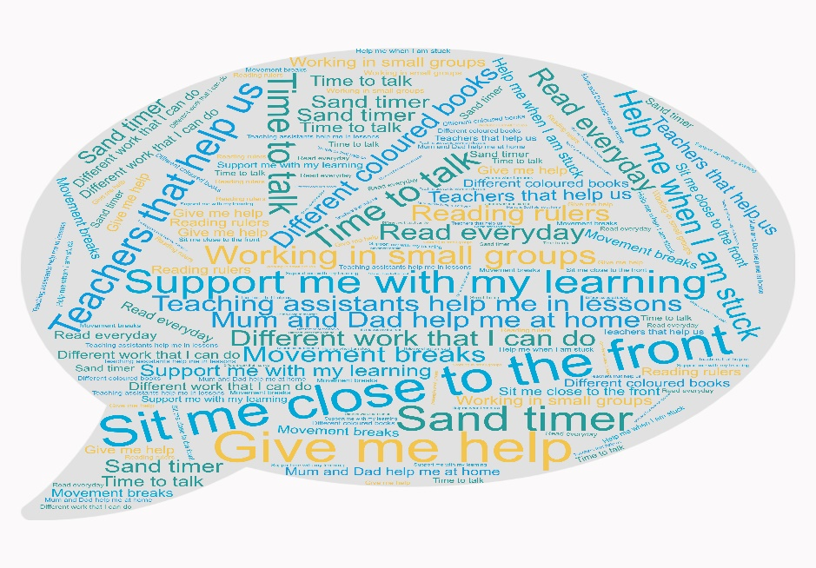

What specialist service and expertise are available at or accessed by the school?

In school we offer a range of both academic and therapeutic interventions, including, but not limited to:

- Talk Boost
- Smart moves (Gross motor Skills)
- Phonics – Little Wandle
- Reading Recovery assistants

- Nessy – Dyslexia/Reading Spelling programme
- Handwriting
- ELSA (Emotional Literacy Support)
- Sand Tray Therapy
- Lego Therapy (Social Skills)
Occasionally, in order to support the identified needs of your child, the school will seek advice and support from other professionals. We work in collaboration with a range of services and professionals who can support your child.
These include:
- School Nurse
- Early Help – Compass team
- Educational psychologist (EP)
- Speech and Language Therapist (SaLT)
- Occupational Therapist (OT)
- Behaviour support team
- Inclusion Support Team
- Consultant paediatrician (Paed)
- Autism Spectrum Disorder Hub (ASD)
- SENCo Cluster – Providing professionals from within the authority on a consult basis
In addition to these services, schools can access social services if there are additional concerns.
How will you help me to support my child‘s learning? How will I be involved in discussions about planning for my child’s education?
We value communication and the sharing of ideas and information between home and school. In addition to twice yearly parent interviews and an annual report, support provided through interventions specified on an Individual Support Plan will be shared with parents and carers at each review point or when there are changes. Parents are encouraged to make an appointment with their child’s class teacher as queries arise or with the SENCO if there are unresolved or complex issues.
We share information with families from the authority about courses on offer to address specific needs and we encourage parents to attend such workshops and to be pro-active in helping to understand the presenting needs and to be able to support their child at home and at school.
The information and support we offer is specific to match the needs of individual children. In addition, please refer to the local offer for further links to organisations which can support parents and carers.
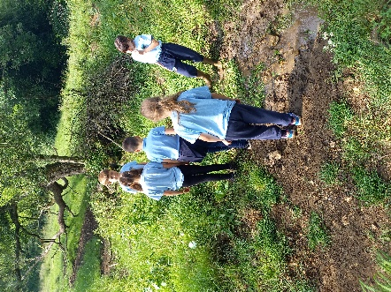
How will my child be included in activities outside the classroom including school trips?
We offer children a wide range of extra-curricular activities and activities to enjoy. Some clubs are run by school staff and some by external professionals all with appropriate qualifications and enhanced DBS clearance. School trips, including residentials, happen regularly and highly enrich learning from both an academic and social aspect. All children regardless of their level of ability are encouraged to participate with these activities. Any trip or extra activity will be discussed with parents and carers so that the right decisions and provision can be made. Every effort will be made to prevent barriers to participation in these activities in line with risk assessments being completed.
How accessible is the school environment?
We have an accessibility plan in place and where feasible, make reasonable adjustments to improve the accessibility to our environment to meet individual needs. Our policy and practice adheres to the Equality Act 2010.
How will the school prepare and support my child to join the school, to transfer to Key Stage 3 or to transfer mid-primary school?
The first day at school can be both exciting and/or stressful. We would always encourage children to make a visit to school beforehand to enable them to become familiar with the setting and with key staff. During this visit teachers can liaise with parents and carers to share information about the best approach to take when the child starts attending school formally. Some children prefer a formal introduction to the class while others prefer to be more discrete and to be introduced to a buddy who will look after them while they get used to the class setup.
When transferring from one primary school to another, South Glos aim for all electronic and paper records will be sent to the receiving school within 15 days of the child leaving.
Moving on or transition can be hard for many children but especially those with SEND. To aid a smooth transition, children can make visits to their new class during the final weeks of the previous term. This can also include visits to Secondary schools where familiar Primary school staff can accompany them. Meetings between parents / carers, key primary and secondary school staff can be arranged to enable effective information sharing and for important questions to be addressed.
For children identified as having SEND by their previous setting, for example in the case of new reception starters or mid-year transfer, early communication is key. In most instances, we are able to contact the previous setting before a child begins at Wick CE Primary school, ensuring we are best placed to meet their needs from the first day they arrive at our school.


How are the school’s resources allocated and matched to children’s special educational needs?
The school budget is decided by the Head of School, the Executive head and SEND governor adhering to strict guidance from South Gloucestershire LEA.
Human resources and interventions are closely monitored to ensure value for money.
Within budgetary constraints, support is allocated according to the level of need.
Additional funding can be applied for where needs for individuals are judged to be exceptional. Parents / carers would be consulted prior to an application being made for an Educational Health and Care Plan (EHCP) funding.
Parents may make their own request to the LA for a needs assessment if they so wish. This may or may not lead to an EHCP being issued.
How is the decision made about how much support my child will receive?
We strive to provide a stimulating and inclusive education alongside quality first teaching. Sometimes, pupils need support which is different or additional to that of their peers. Any adjustments or interventions put in place for a child will be clearly detailed and shared with parents / carers as necessary and may also be recorded on an individual provision map specific to the child or a small group of children.
Who can I contact for further information?
In the first instance, parents and carers are encouraged to contact the child’s class teacher. For pupils with SEND, further information and support can be sought from the SENCo, Mrs Barrett.

Parents and carers are also able to contact the Head Teacher or SEN governor.
Independent advice and guidance can be found through SEND and You https://www.sendandyou.org.uk/
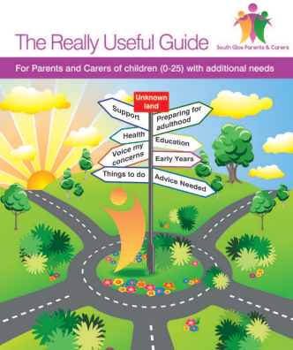
South Glos Parents and Carers group provide a useful booklet with further guidance for Parents and Carers of children with additional needs. Please click here.

